* <https://docs.microsoft.com/en-us/azure/storage/blobs/storage-blobs-introduction>
* 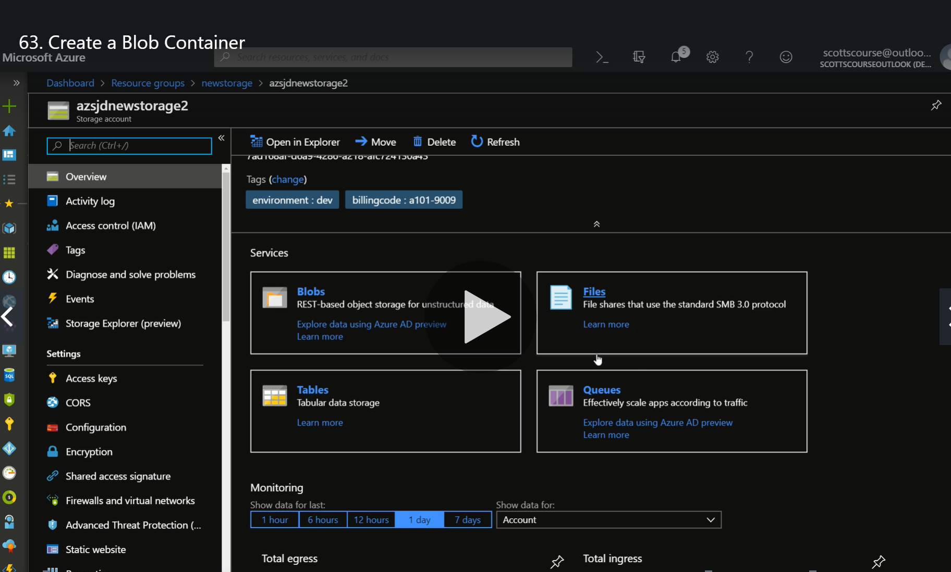
* Blob are used to store unstructured data.
* They are simple containers which we can use to store files.
* While creating a container we require name, provide public access level.
* 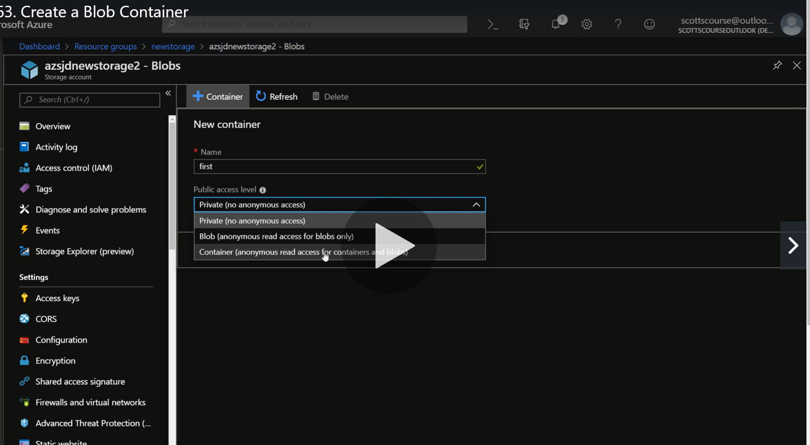
* We can upload the file from the portal directly by setting the authentication for the file and everything.
* Containers do not have folder structures but in blob containers they virtually create it for showing.